SIMATS ENGINEERING
CONTINOUS INTERNAL ASSESSMENT- ANALYTICAL PROBLEM SOLVING
COURSE NAME: DATABASE MANAGEMENT SYSTEMS
COURSE CODE: CSA05
COURSE OUTCOME COVERED
CO2: Apply the relational model, relational algebra, SQL query structures, and views to solve database querying and data manipulation problems. (BL3, BL6)
Questions:05 Total marks:100
Annexure A
ANALYTICAL PROBLEM SOLVING
Code of Conduct:
I M D.GLADWIN(192565046) (Name / Reg No) certify that this submission is my original work and that I have adhered to the guidelines specified for this assessment.
I understand that any violation of academic integrity rules will result in disciplinary action.
Signature of the student: D.GLADWIN

ANNEXURE ANALYTICAL PROBLEM SOLVING
QUESTIONS
Q.No | Question | Bloom's Level
1 | An organization maintains EMPLOYEE(Emp_ID, Emp_Name, Salary, Dept_ID) and DEPARTMENT(Dept_ID, Dept_Name, Location)  relations. Using the given relations, apply selection (σ), projection (π), union (∪), set difference (−), Cartesian product (×), and join (⋈) operations to retrieve employees belonging to a particular department, department details, and employee–department information. | BL3 – Apply
2 | A university maintains STUDENT(SID, Name, DOB, DeptID) and  DEPARTMENT(DeptID, DeptName) tables. Write SQL CREATE  TABLE statements with suitable PRIMARY KEY, FOREIGN KEY, NOT NULL, UNIQUE, CHECK, and DEFAULT constraints. Ensure that referential integrity is maintained between the two tables. | BL3 – Apply
3 | A retail company maintains a SALES(Sale_ID, Product_ID,  Customer_ID, Quantity, Unit_Price, Sale_Date) relation. Formulate SQL queries using GROUP BY, HAVING, and aggregate functions such as COUNT, SUM, AVG, MAX, and MIN to generate productwise sales summaries, identify high-value products, and retrieve groups satisfying specified conditions. | BL3 – Apply
4 | A company maintains EMPLOYEE(Emp_ID, Emp_Name, Salary,  Dept_ID) records. Write a correlated subquery to identify employees whose salary is greater than the average salary of other employees working in the same department. Explain how the inner query is related to the outer query for each employee. | BL3 – Apply
5 | A software company maintains EMPLOYEE(Emp_ID, Emp_Name, Dept_ID) and PROJECT(Project_ID, Project_Name, Emp_ID) relations. Apply INNER JOIN, LEFT OUTER JOIN, RIGHT OUTER JOIN, FULL OUTER JOIN, and CROSS JOIN to retrieve employee–project information. Explain the type of result produced by each join operation. | BL3 – Apply
RUBRICS FOR CALCULATION:
Criteria | Weightage | Level 4 (Exemplary) | Level 3 (Proficient) | Level 2 (Developing) | Level 1 (Beginning)
Problem Understanding | 20% | Clearly interprets problem,  identifies all  parameters and  requirements  accurately | Understands problem with minor gaps | Partial understanding; misses key elements | Misinterprets or unable to  understand problem
Method  Selection | 20% | Selects most appropriate  method/formula with strong justification | Selects correct  method with minor errors | Inappropriate or partially correct method | Unable to select method
Solution Process | 25% | Logical, systematic steps with correct approach throughout | Mostly correct steps  with minor mistakes | Disorganized steps; multiple errors | No clear process
Accuracy of Calculation | 20% | All calculations accurate;  correct final answer | Minor calculation errors | Frequent errors;  incorrect final answer | No valid calculations
Interpretation of Results | 15% | Clearly interprets  results with units and  engineering relevance | Basic interpretation  with minor omissions | Limited or unclear interpretation | No interpretation

- Relational Algebra Operations on EMPLOYEE and DEPARTMENT Relations
The organization maintains two relations:
- EMPLOYEE (Emp_ID, Emp_Name, Salary, Dept_ID)
- DEPARTMENT (Dept_ID, Dept_Name, Location)
Relational algebra is used to retrieve and manipulate data from relations using different operations.
1. Selection (σ)
Selection retrieves rows that satisfy a specified condition.
Query: Retrieve employees belonging to department 10.
\[ \sigma_{\text{Dept\_ID}=10}(\text{EMPLOYEE}) \]
Explanation: Displays all employee records whose department ID is 10.
2. Projection (π)
Projection retrieves specific columns from a relation.
Query: Display department names and locations.
\[ \pi_{\text{Dept\_Name, Location}}(\text{DEPARTMENT}) \]
Explanation: Displays only the department name and location, removing other columns and duplicate rows.
3. Union (∪)
Union combines the rows of two union-compatible relations. Both relations must have the same number of attributes with compatible domains.
Query: Retrieve the employee IDs of employees working in department 10 or department 20.
\[ \pi_{\text{Emp\_ID}}(\sigma_{\text{Dept\_ID}=10}(\text{EMPLOYEE})) \]
\[ \cup \]
\[ \pi_{\text{Emp\_ID}}(\sigma_{\text{Dept\_ID}=20}(\text{EMPLOYEE})) \]
Explanation: Returns the employee IDs from both departments without duplicates.
4. Set Difference (−)
Set difference retrieves records present in one relation but absent from another union-compatible relation.
Query: Retrieve employees who do not belong to department 10.
\[ \pi_{\text{Emp\_ID}}(\text{EMPLOYEE}) - \pi_{\text{Emp\_ID}}(\sigma_{\text{Dept\_ID}=10}(\text{EMPLOYEE})) \]
Explanation: Displays the IDs of employees who are not assigned to department 10.
5. Cartesian Product (×)
The Cartesian product combines every row of one relation with every row of another relation.
Query: Combine EMPLOYEE and DEPARTMENT relations.
\[ \text{EMPLOYEE} \times \text{DEPARTMENT} \]
Explanation: Produces all possible employee–department combinations. If EMPLOYEE contains \(m\) rows and DEPARTMENT contains \(n\) rows, the result contains \(m \times n\) rows.
6. Join (⋈)
Join combines related records from two relations using a common attribute.
Query: Retrieve employee names along with their department names and locations.
\[ \text{EMPLOYEE} \bowtie_{\text{EMPLOYEE.Dept\_ID}=\text{DEPARTMENT.Dept\_ID}} \text{DEPARTMENT} \]
Explanation: Matches employees with their corresponding departments using Dept_ID.
To display only the required information:
\[ \pi_{\text{Emp\_Name, Dept\_Name, Location}} \]
\[ (\text{EMPLOYEE} \bowtie_{\text{EMPLOYEE.Dept\_ID}=\text{DEPARTMENT.Dept\_ID}} \text{DEPARTMENT}) \]
Explanation: Displays each employee's name, department name, and department location.

Therefore, Relational algebra operations help retrieve and manipulate database information. Selection filters rows, projection selects columns, union combines compatible results, set difference finds unmatched records, Cartesian product creates all combinations, and join combines related information from multiple relations.

2) SQL CREATE TABLE Statements with Constraints
1. Create DEPARTMENT Table
Query :
CREATE TABLE DEPARTMENT (
DeptID INT PRIMARY KEY,
DeptName VARCHAR(50) NOT NULL UNIQUE
);
Output:
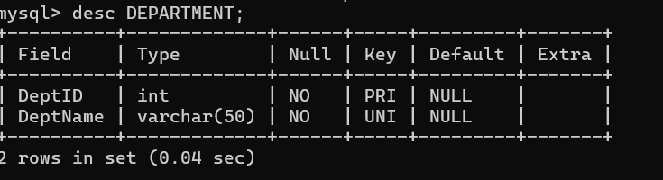
Constraints used:
- PRIMARY KEY: Ensures each department has a unique ID.
- NOT NULL: Department name cannot be empty.
- UNIQUE: Prevents duplicate department names.
2. Create STUDENT Table
CREATE TABLE STUDENT (
SID INT PRIMARY KEY,
Name VARCHAR(50) NOT NULL,
DOB DATE NOT NULL,
DeptID INT NOT NULL,
Email VARCHAR(100) UNIQUE,
Age INT CHECK (Age >= 17),
Status VARCHAR(20) DEFAULT 'Active',
FOREIGN KEY (DeptID)
REFERENCES DEPARTMENT(DeptID)
);

Output:
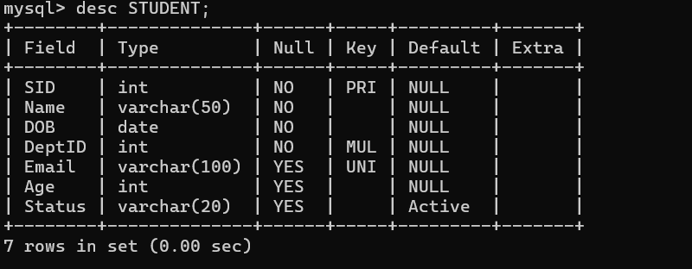

Constraints used:
- PRIMARY KEY: Uniquely identifies each student.
- NOT NULL: Student name, date of birth, and department ID must be provided.
- UNIQUE: Ensures each email address is unique.
- CHECK: Ensures the student's age is at least 17.
- DEFAULT: Sets the status to 'Active' when no value is provided.
- FOREIGN KEY: Ensures that the student's DeptID exists in the DEPARTMENT table.
Note: The Age column is added as an example to demonstrate the CHECK constraint.
Referential Integrity
The FOREIGN KEY (DeptID) constraint ensures that a student cannot be assigned to a department that does not exist in the DEPARTMENT table.
Example insertion order:
INSERT INTO DEPARTMENT
VALUES (101, 'Computer Science');

INSERT INTO STUDENT
(SID, Name, DOB, DeptID, Email, Age)
VALUES
(1, 'Arun', '2005-06-15', 101,
'arun@example.com', 21);

Output:
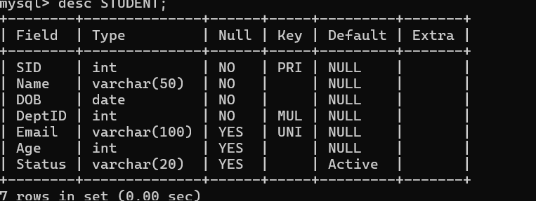

- SQL Queries Using GROUP BY, HAVING, and Aggregate Functions
The company maintains the SALES relation:
SALES(Sale_ID, Product_ID, Customer_ID, Quantity, Unit_Price, Sale_Date)
1. Create SALES Table
CREATE TABLE SALES (
Sale_ID INT PRIMARY KEY,
Product_ID INT NOT NULL,
Customer_ID INT NOT NULL,
Quantity INT CHECK (Quantity > 0),
Unit_Price DECIMAL(10,2) CHECK (Unit_Price >= 0),
Sale_Date DATE
);
2. Insert Sample Records
INSERT INTO SALES VALUES
(1, 101, 201, 5, 1000, '2026-01-10'),
(2, 102, 202, 3, 2000, '2026-01-11'),
(3, 101, 203, 4, 1000, '2026-01-12'),
(4, 103, 204, 10, 500, '2026-01-13'),
(5, 102, 205, 6, 2000, '2026-01-14'),
(6, 101, 206, 2, 1000, '2026-01-15'),
(7, 103, 207, 8, 500, '2026-01-16');

Output:
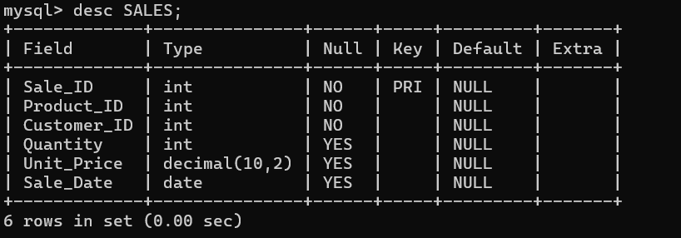

3. Product-wise Total Sales Using SUM()
SELECT Product_ID,
SUM(Quantity * Unit_Price) AS Total_Sales
FROM SALES
GROUP BY Product_ID;
Output:
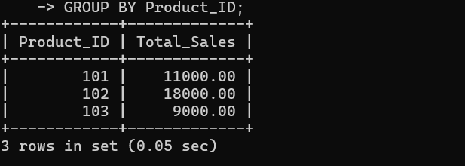

4. Count Total Sales Using COUNT()
SELECT Product_ID,
COUNT(Sale_ID) AS Total_Orders
FROM SALES
GROUP BY Product_ID;
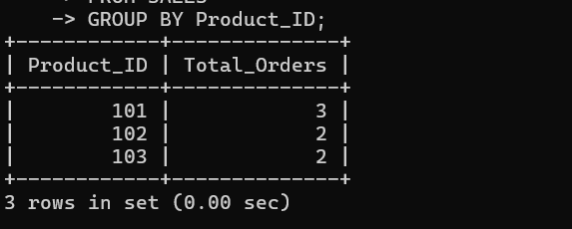

5. Find Average Sales Using AVG()
SELECT Product_ID,
AVG(Quantity * Unit_Price) AS Average_Sales
FROM SALES
GROUP BY Product_ID;
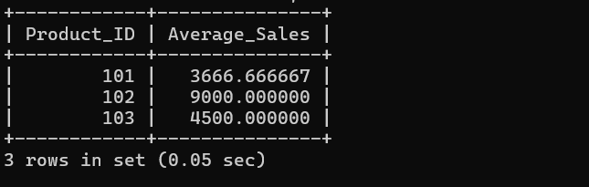

6. Find Maximum Sale Using MAX()
SELECT Product_ID,
MAX(Quantity * Unit_Price) AS Maximum_Sale
FROM SALES
GROUP BY Product_ID;
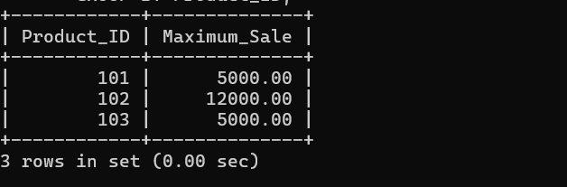

7. Find Minimum Sale Using MIN()
SELECT Product_ID,
MIN(Quantity * Unit_Price) AS Minimum_Sale
FROM SALES
GROUP BY Product_ID;
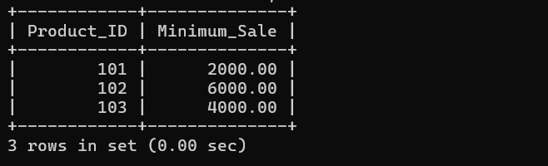

8. Identify High-Value Products Using HAVING
SELECT Product_ID,
SUM(Quantity * Unit_Price) AS Total_Sales
FROM SALES
GROUP BY Product_ID
HAVING SUM(Quantity * Unit_Price) > 10000;
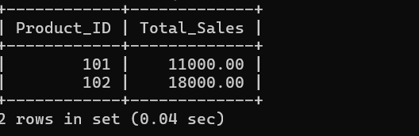

9. Find Products Having More Than Two Sales Records
SELECT Product_ID,
COUNT(Sale_ID) AS Total_Orders
FROM SALES
GROUP BY Product_ID
HAVING COUNT(Sale_ID) > 2;
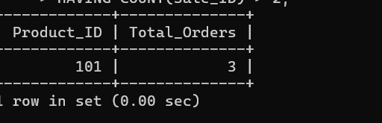

10. Find Products with Average Quantity Greater Than 5
SELECT Product_ID,
AVG(Quantity) AS Average_Quantity
FROM SALES
GROUP BY Product_ID
HAVING AVG(Quantity) > 5;
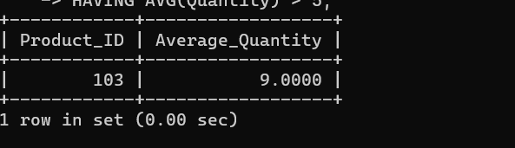

11. Display Complete Product-wise Sales Summary
SELECT Product_ID,
COUNT(Sale_ID) AS Total_Orders,
SUM(Quantity) AS Total_Quantity,
SUM(Quantity * Unit_Price) AS Total_Sales,
AVG(Quantity * Unit_Price) AS Average_Sales,
MAX(Quantity * Unit_Price) AS Maximum_Sale,
MIN(Quantity * Unit_Price) AS Minimum_Sale
FROM SALES
GROUP BY Product_ID;
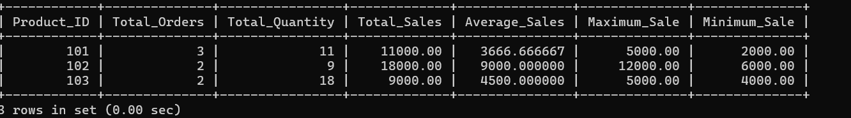

Result
These queries calculate product-wise sales summaries, count sales records, find average, maximum and minimum sale amounts, and identify products satisfying specified conditions using GROUP BY and HAVING.

4) SQL Program: Correlated Subquery
1. Create EMPLOYEE Table
CREATE TABLE EMPLOYEE (
Emp_ID INT PRIMARY KEY,
Emp_Name VARCHAR(50) NOT NULL,
Salary DECIMAL(10,2) CHECK (Salary > 0),
Dept_ID INT NOT NULL
);
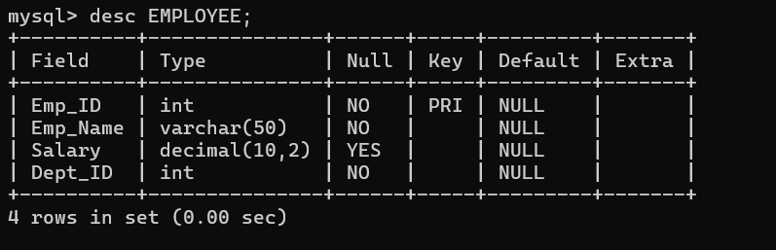

2. Insert Sample Records
INSERT INTO EMPLOYEE VALUES
(101, 'Arun', 50000, 10),
(102, 'Bala', 40000, 10),
(103, 'Kumar', 60000, 10),
(104, 'Priya', 45000, 20),
(105, 'Divya', 35000, 20),
(106, 'Ravi', 55000, 20);

3. Correlated Subquery
Query: Identify employees whose salary is greater than the average salary of other employees in the same department.
SELECT E.Emp_ID, E.Emp_Name, E.Salary, E.Dept_ID
FROM EMPLOYEE E
WHERE E.Salary > (
SELECT AVG(E2.Salary)
FROM EMPLOYEE E2
WHERE E2.Dept_ID = E.Dept_ID
AND E2.Emp_ID <> E.Emp_ID
);
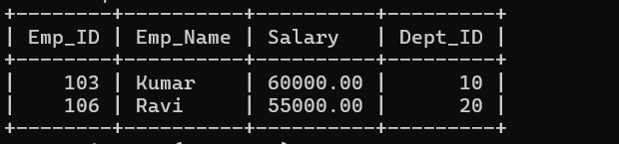

4. Explanation
- Outer query (E): Selects each employee's ID, name, salary, and department.
- Inner query (E2): Calculates the average salary of other employees in the same department.
- Correlation condition: E2.Dept_ID = E.Dept_ID connects the inner query to the department of the current outer employee.
- Exclusion condition: E2.Emp_ID <> E.Emp_ID excludes the current employee from the average calculation.
- Comparison: The outer query returns employees whose salary is greater than that calculated average.

Result:
A correlated subquery depends on values from the outer query. Here, the inner query executes logically for each employee, calculating the average salary of other employees in the same department. The outer query then identifies employees earning more than that average.

- SQL Program: Different Types of JOIN Operations
The company maintains two tables:
- EMPLOYEE(Emp_ID, Emp_Name, Dept_ID)
- PROJECT(Project_ID, Project_Name, Emp_ID)
1. Create EMPLOYEE Table
CREATE TABLE EMPLOYEE (
Emp_ID INT PRIMARY KEY,
Emp_Name VARCHAR(50) NOT NULL,
Dept_ID INT
);
2. Create PROJECT Table
CREATE TABLE PROJECT (
Project_ID INT PRIMARY KEY,
Project_Name VARCHAR(50) NOT NULL,
Emp_ID INT,
FOREIGN KEY (Emp_ID) REFERENCES EMPLOYEE(Emp_ID)
);
3. Insert Sample Records
INSERT INTO EMPLOYEE VALUES
(101, 'Arun', 10),
(102, 'Bala', 20),
(103, 'Priya', 10),
(104, 'Ravi', 30);
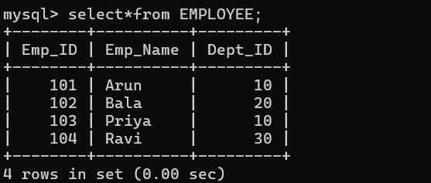

INSERT INTO PROJECT VALUES
(1, 'Website', 101),
(2, 'Mobile App', 102),
(3, 'Database', 101);
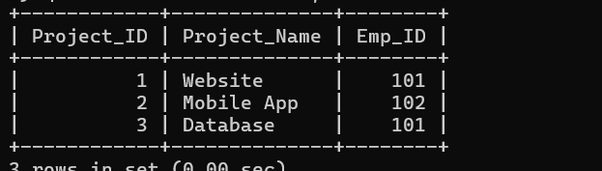

4. INNER JOIN
SELECT E.Emp_ID, E.Emp_Name,
P.Project_ID, P.Project_Name
FROM EMPLOYEE E
INNER JOIN PROJECT P
ON E.Emp_ID = P.Emp_ID;
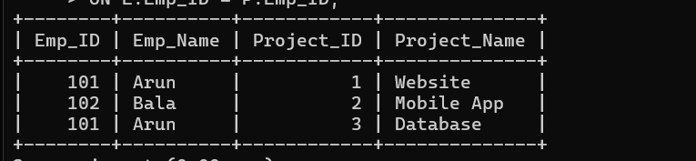
Explanation: Returns only employees who are assigned to projects.

5. LEFT OUTER JOIN
SELECT E.Emp_ID, E.Emp_Name,
P.Project_ID, P.Project_Name
FROM EMPLOYEE E
LEFT OUTER JOIN PROJECT P
ON E.Emp_ID = P.Emp_ID;
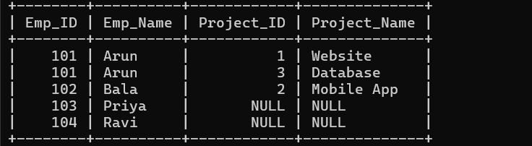
Explanation: Returns all employees, including those without projects. Project columns contain NULL when no matching project exists.

6. RIGHT OUTER JOIN
SELECT E.Emp_ID, E.Emp_Name,
P.Project_ID, P.Project_Name
FROM EMPLOYEE E
RIGHT OUTER JOIN PROJECT P
ON E.Emp_ID = P.Emp_ID;
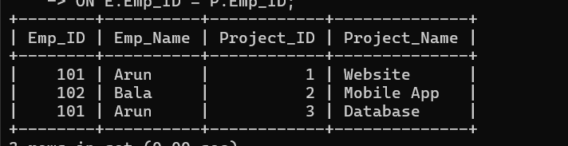
Explanation: Returns all projects, including projects without a matching employee. Employee columns contain NULL when no match exists. The foreign key in this example prevents such unmatched project records under normal constraint enforcement.

7. FULL OUTER JOIN
SELECT E.Emp_ID, E.Emp_Name,
P.Project_ID, P.Project_Name
FROM EMPLOYEE E
FULL OUTER JOIN PROJECT P
ON E.Emp_ID = P.Emp_ID;
Explanation: Returns all matching employee–project records and all unmatched records from both tables, filling missing columns with NULL.
Note: MySQL does not directly support FULL OUTER JOIN. In MySQL, it can be simulated using a LEFT JOIN, UNION, and RIGHT JOIN or an equivalent query.

8. CROSS JOIN
SELECT E.Emp_ID, E.Emp_Name,
P.Project_ID, P.Project_Name
FROM EMPLOYEE E
CROSS JOIN PROJECT P;
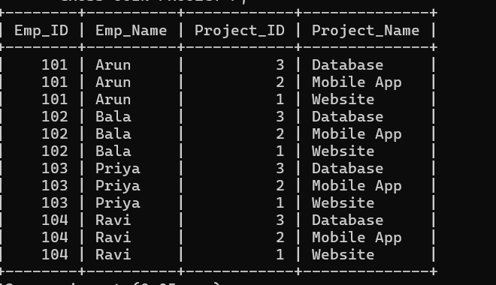
Explanation: Combines every employee with every project, regardless of whether the employee is assigned to that project. With 4 employees and 3 projects, the result contains \(4 \times 3 = 12\) rows.

Summary of JOIN Operations
JOIN type | Result
INNER JOIN | Only matching records
LEFT OUTER JOIN | All employees and matching projects
RIGHT OUTER JOIN | All projects and matching employees
FULL OUTER JOIN | All records from both tables
CROSS JOIN | Every possible employee–project combination

Result:
JOIN operations combine data from multiple tables based on matching conditions or combinations. They help retrieve employee–project information according to different requirements.

